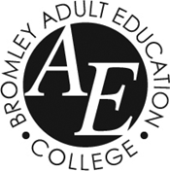

LEARNER CODE OF CONDUCT 2020-2021

Learners with Learning Difficulties and Disabilities (LLDD)

RATIONALE

Bromley Adult Education College (BAEC) is committed to providing a first class learning environment. BAEC has responsibility to those attending the LLDD provision to provide high professional standards of teaching and a safe and motivating place for learning.

By enrolling on a BAEC course, learners, parents and carers confirm that they are committed to abiding to this Learner Code of Conduct.

This Code includes:
- BAEC’ definition of Unacceptable Behaviour
- Personal Care
- Learners’ responsibilities and expectations
- Stages in the College disciplinary procedure
- New Covid19 Risk Management Procedures

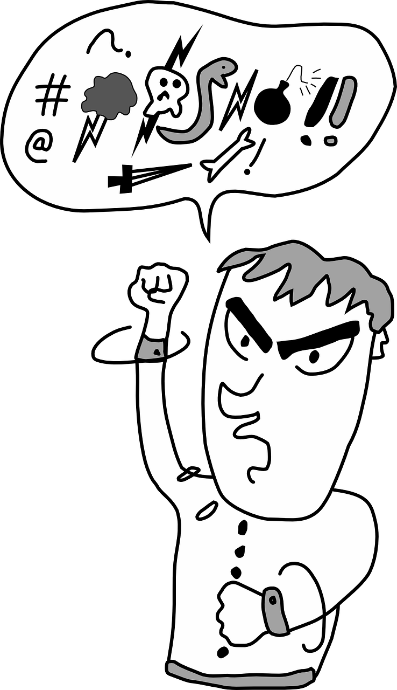
UNACCEPTABLE BEHAVIOUR

Unacceptable behaviour is defined as “any behaviour which impacts negatively on teaching, learning, assessment and progress of learners”

BAEC has a zero tolerance policy concerning behaviour by an individual or individuals which negatively impacts on the wellbeing or educational outcomes of another learner or group of learners.

Examples of unacceptable behaviour/misconduct that may lead to disciplinary action are listed below:

- Discriminatory, sexist, racist, offensive or abusive charged language conveyed verbally or electronically
- Intimidating verbal or physical behaviour towards learners or members of staff
- Causing deliberate upset in shared spaces by not respecting others’ right to drink, eat or speak together
- Deliberate misuse of, damage to, misappropriation or theft of any learning material and/or equipment, furniture, fittings or other property belonging to BAEC or its learners or staff
- Abuse of computer facilities through installation of personal or illegal software or otherwise engage in other activities which may disrupt the computer network or infringe the IT User Code of Conduct
- Cheating or copying other learners’ work
- Anti social, disruptive or sexually suggestive behaviour physically, verbally or electronically e.g. any behaviour that infringes upon other learners ability to learn or wellbeing

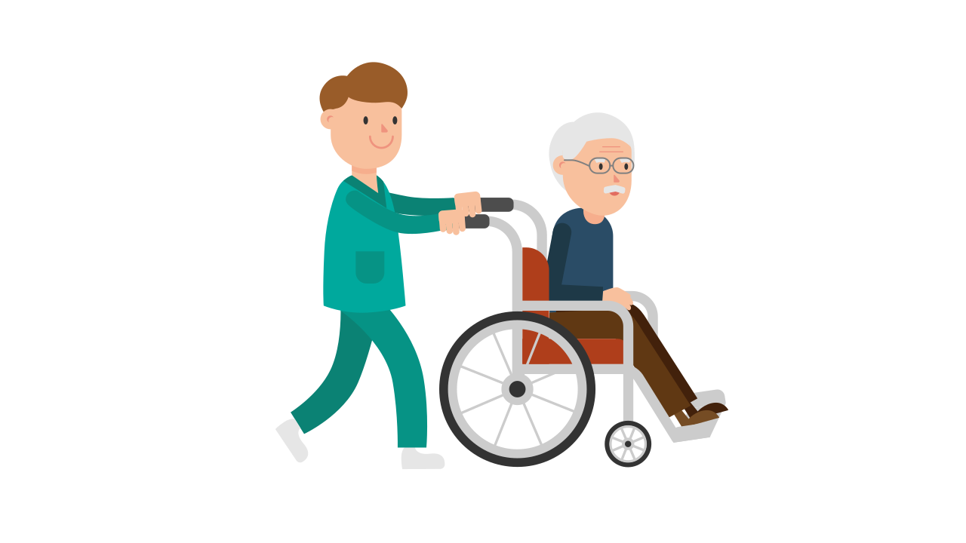
PERSONAL CARE

BAEC staff is unable to offer any personal care to learners attending theLLDD provision. Learners, carers and parents should be aware of this and make appropriate provision for any personal care which learners may need. This may include:
- Toileting needs
- Pushing wheelchairs
- Assisting with eating or drinking
- Administration or supervision of medicines
- Helping with seizures
- Other personal care activities

LEARNERS’ RESPONSIBILITIES

Learners must:
- Formally enrol for classes which they are attending
- Recognise and observe BAEC policies and procedures
- Show respect to others
- Not share or send any electronic texts, messages or images containing discriminatory, sexist, racist, offensive or abusive content with other BAEC learners
- Respect the personal space of other learners and physical contact should relate only to creative dance and drama tasks

Respect the wishes of other learners and
- Allow others to learn and work without interruption or disruption
- Attend classes regularly and punctually
- Provide proof of enrolment/identity/eligibility when required
- Observe all health and safety regulations as well as additional rules in specific areas such as table areas during the breaks, garden and other outside areas
- Observe the no smoking / no vaping regulations inside the premises
- Eat and drink only in designated areas (it is permitted to take bottled water into classrooms but not into IT suites)
- Follow the emergency evacuation procedures
- Recognise that the tutor has a responsibility for the learning of the whole group
- Respect and not cause damage to equipment, materials or buildings
- Behave with consideration to others when using shared spaces including the refreshment and reception areas, outside space and toilet facilities
- Follow the course behaviour guidelines known as ground or college rules agreed by the group during the first session

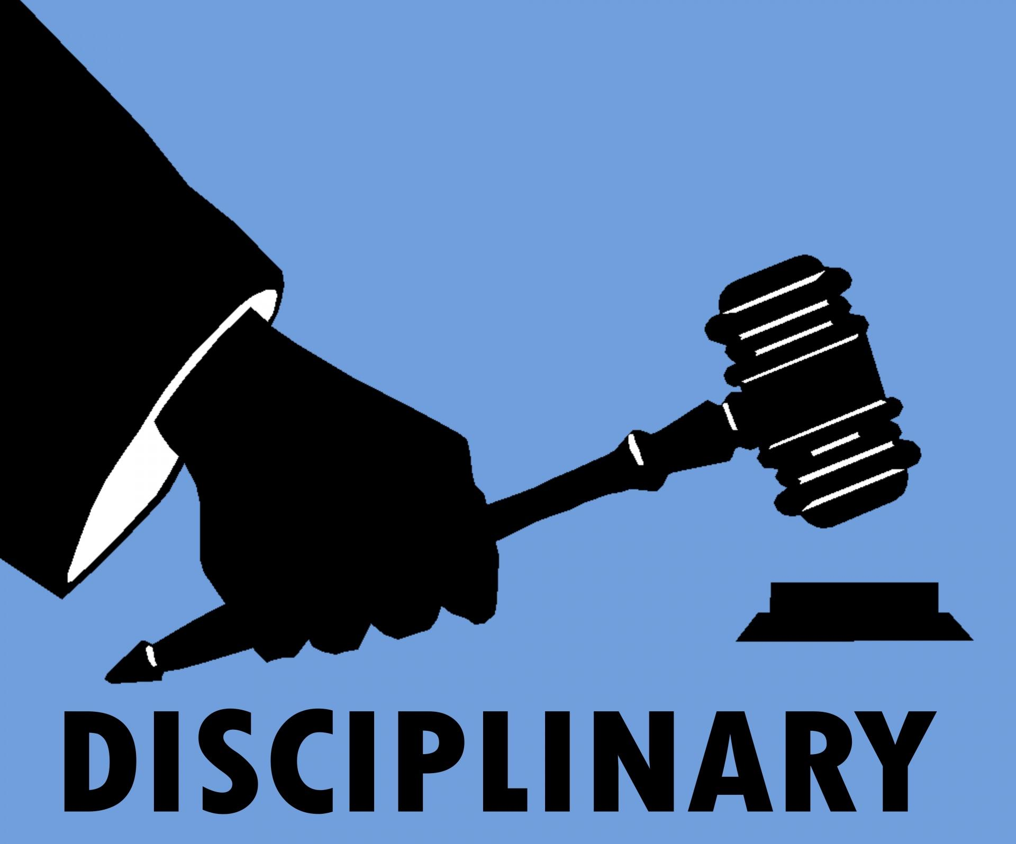

DISCIPLINARY PROCEDURE

INCIDENT
Stage 1 (Pre-disciplinary procedure)
A member of staff issues a verbal warning informing the learner that their behaviour is unacceptable and infringes the BAEC Code of Conduct.
A letter confirming the verbal warning will be sent to the learner/carer. A copy of the letter is also sent to the BAEC Safeguarding Team who are made aware of the incident.

Stage 2 (Start of disciplinary procedure)
A member of staff issues a second verbal warning. A written report of the incident will be made. A formal letter is sent to the learner and their carer by the relevant subject area manager with a copy to the tutor involved. The learner and their carer are invited to a meeting with the BAEC Safeguarding Team.

Stage 3 (Intermediate stage of the disciplinary procedure)
Should the behaviour continue, the Head of Adult Learning invites the learner to a panel meeting (which will include representation from the BAEC Safeguarding Team). The outcome of the panel meeting will be conveyed to the learner / carer in writing within 5 working days following the meeting.

Stage 4 (Final stage of the disciplinary procedure)
If appropriate, the Head of Adult Learning excludes the learner whilst the investigation is being carried out. The Head of Adult Learning and the panel determine the duration of the exclusion period and whether the exclusion should be permanent. A letter is sent to the learner and their carer explaining the decision and the reasons for this decision.

SERIOUS INCIDENTS
A serious incident could lead to immediate dismissal from the premises and will be dealt with by the most senior person on site. The police will be called (if appropriate). A letter from the Head of Adult Learning will be sent inviting the learner to a meeting. The meeting would take place within 10 working days. The Head of Adult Learning will convene a panel, (which will include representation from the BAEC Safeguarding Team) taking into account the nature and circumstances of the incident. Whilst investigations are taking place the learner would be temporarily suspended from attending the college.

Depending on the circumstances, the Head of Adult Learning and the panel determine the duration of the exclusion period and whether the exclusion should be permanent. A letter is sent to the learner and their carer explaining the decision and the reasons for this decision.

Examples of serious incidents might include
- Wilful damage to property
- Sending or downloading electronic texts, messages or images containing discriminatory, sexist, racist, offensive or abusive content, physical violence, serious breach of health and safety, verbal or physically abusive behaviour.
- Inappropriate behaviour of an offensive or sexual nature.

APPEALS
The learner and their carer will be informed about their right of appeal and about the right to be accompanied by an agreed advocate.

Covid19 Risk Management Measures

Each learner, family and carer is responsible for contributing to a safe and healthy college environment by following these measures:
- Do not come to college if you do not feel well
- Wash hands regularly
- Use the sanitisers outside each classroom before and after lessons
- Use antibacterial wipes provided in the Computer Rooms to clean keyboards
- Use the one way system following the signs and directions on the floor and doors
- Respect social distancing at break times and not share tables and chairs with other learners
- Wear a face covering in communal areas, unless you are exempt
- Leave the classroom through the fire exits and meet your family and or carer on the Green Area outside the main entrance

